

Healthy teeth and gums are very important for overall health. Maintaining healthy teeth and gums is easy and will aid in blood sugar control. If you have diabetes, taking care of your mouth is very important. You are at risk for periodontal disease and other infections. Periodontal disease can damage the gum and bone that support your teeth. It may lead to bleeding gums, chewing problems and tooth loss. Periodontal disease may also make it hard to control blood glucose (sugar). Both veterans and their family members should follow these general guidelines:

- Brush your teeth at least twice a day with a soft toothbrush and a fluoride tartar-control toothpaste, and, if you have diabetes, brush after each meal (recent research demonstrates greater effectiveness using electric or battery operated brushes compared with manual brushes).

- Floss your teeth at least once a day at bedtime, then brush.

- If you have a dry mouth, a high rate of tooth decay, or sensitive teeth, your dentist may prescribe a concentrated fluoride solution with directions for home application.


- Diet is important for maintaining good dental health. Avoid the frequent eating of very sugary or sticky foods. Use sugar free products when possible. If you have a problem with worn, cracking or loose teeth, avoid chewing hard foods such as hard candies, nuts, or ice.



- Visit your dentist regularly. Tell your dentist you are diabetic. Tell your dentist if your dentures do not fit or if your gums are sore. Take time to check your mouth regularly for any problems. Sometimes people notice their gums bleed when they brush and floss. Others notice dryness, soreness, white patches, or bad taste in the mouth. All of these are reasons to visit your dentist.

- Quit smoking. Smoking makes gum disease worse. Your physician or dentist can help you quit.

- Advise your children and family members to follow the same dental routine.

- Remember, good blood glucose control can help prevent mouth problems

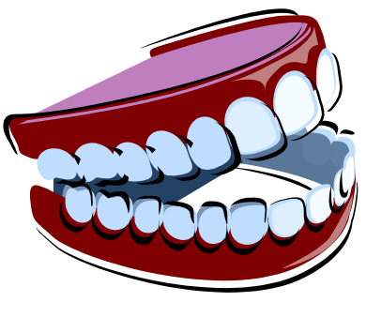
Following these guidelines will keep your mouth healthy and will prevent dental diseases that require more expensive and time-consuming treatment.
http://vaww.wp.webdev.va.gov/diabetes/docs/DentalHygieneSchools.doc
Follow these links to additional resources for oral care:

http://www.health.uab.edu/show.asp?durki=26579
http://www.nidcr.nih.gov/HealthInformation/OralHealthInformationIndex/default.htm
http://www.diabetes.org/type-1-diabetes/mouth-care.jsp
http://www.clevelandclinic.org/health/health-info/docs/3200/3278.asp?index=11263&src=news

